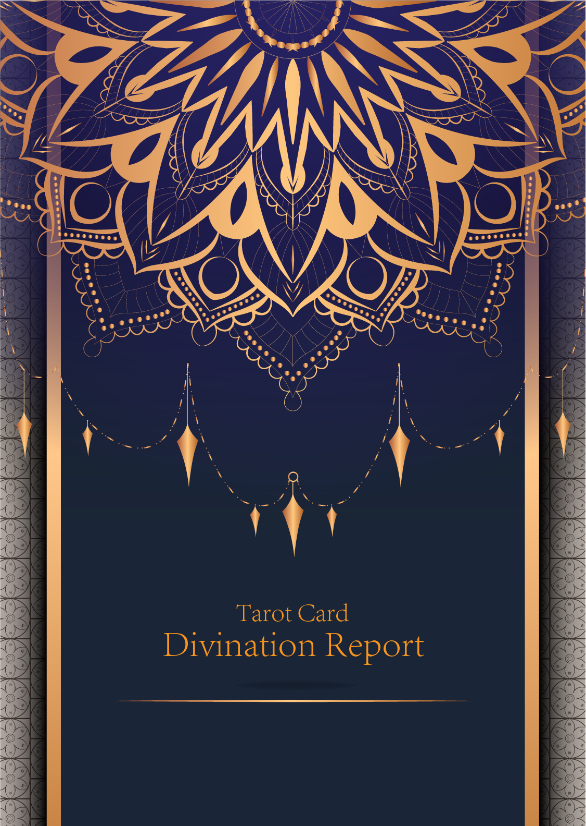

|  |
| --- |
| {{#date}} |

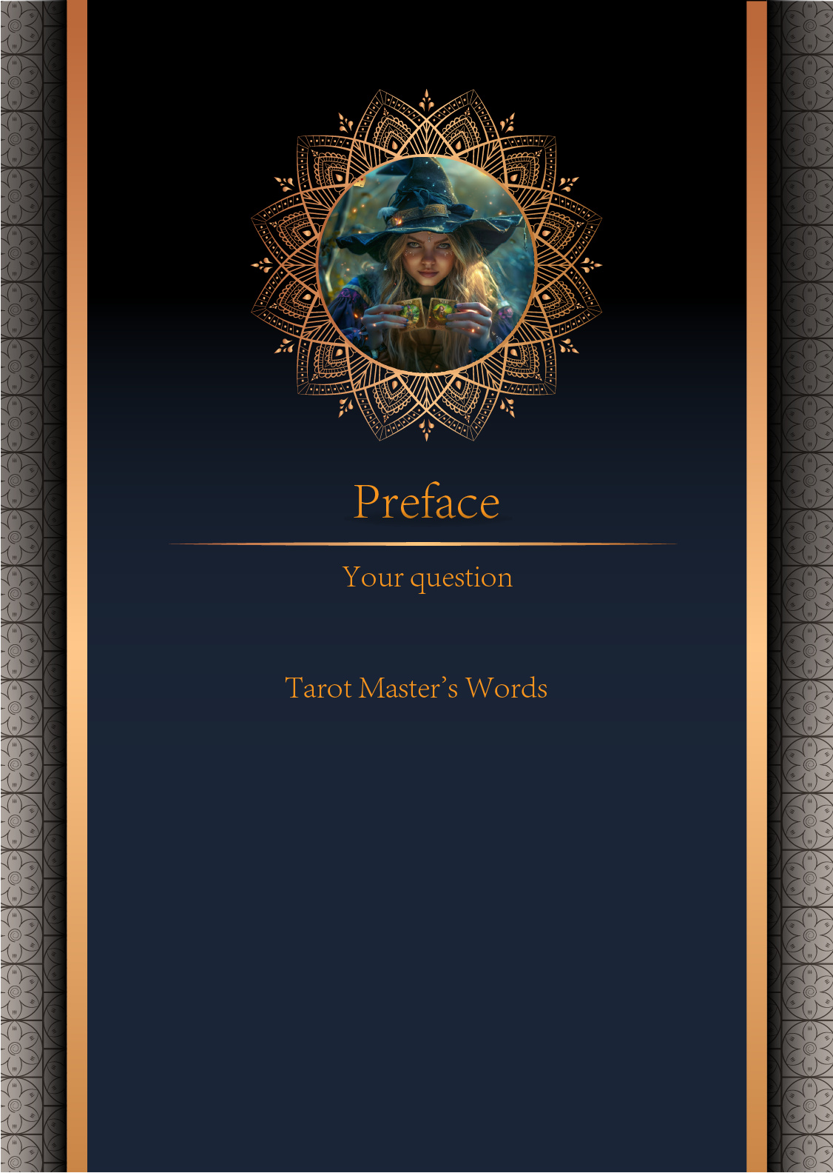

|  |
| --- |
| {{#user_question}} |

|  |
| --- |
| {{#master_words}} |

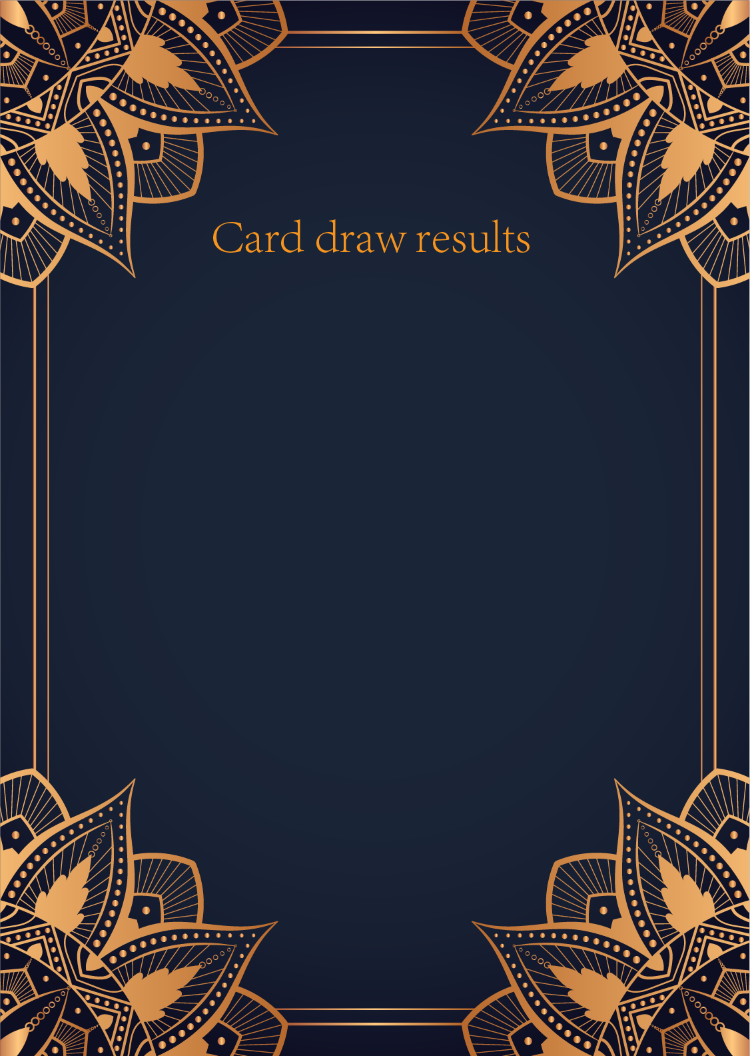

|  |
| --- |
| {{#card_first_name}} |
| {{#card_first_image}} |
| {{#card_first_description}} |

|  |
| --- |
| {{#card_second_name}} |
| {{#card_second_image}} |
| {{#card_second_description}} |

|  |
| --- |
| {{#card_third_name}} |
| {{#card_third_image}} |
| {{#card_third_description}} |

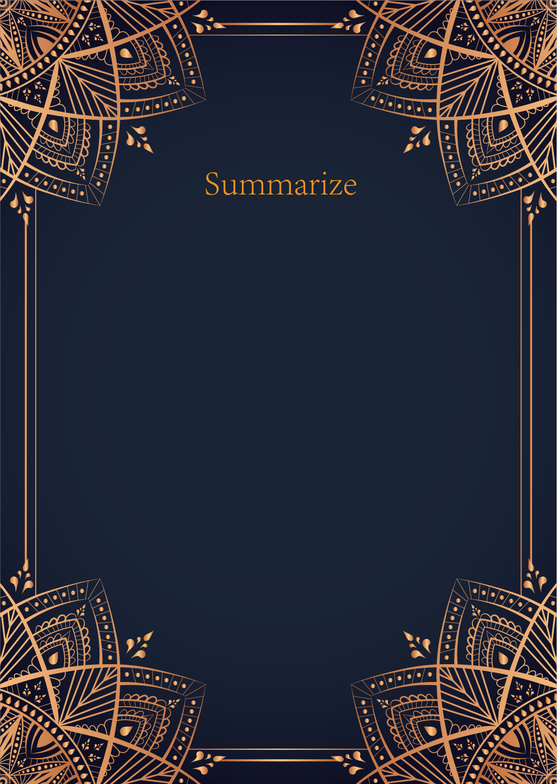

|  |
| --- |
| {{#summarize}} |



|  |
| --- |
| {{#love_suggestion}} |



|  |
| --- |
| {{#career_suggestion}} |

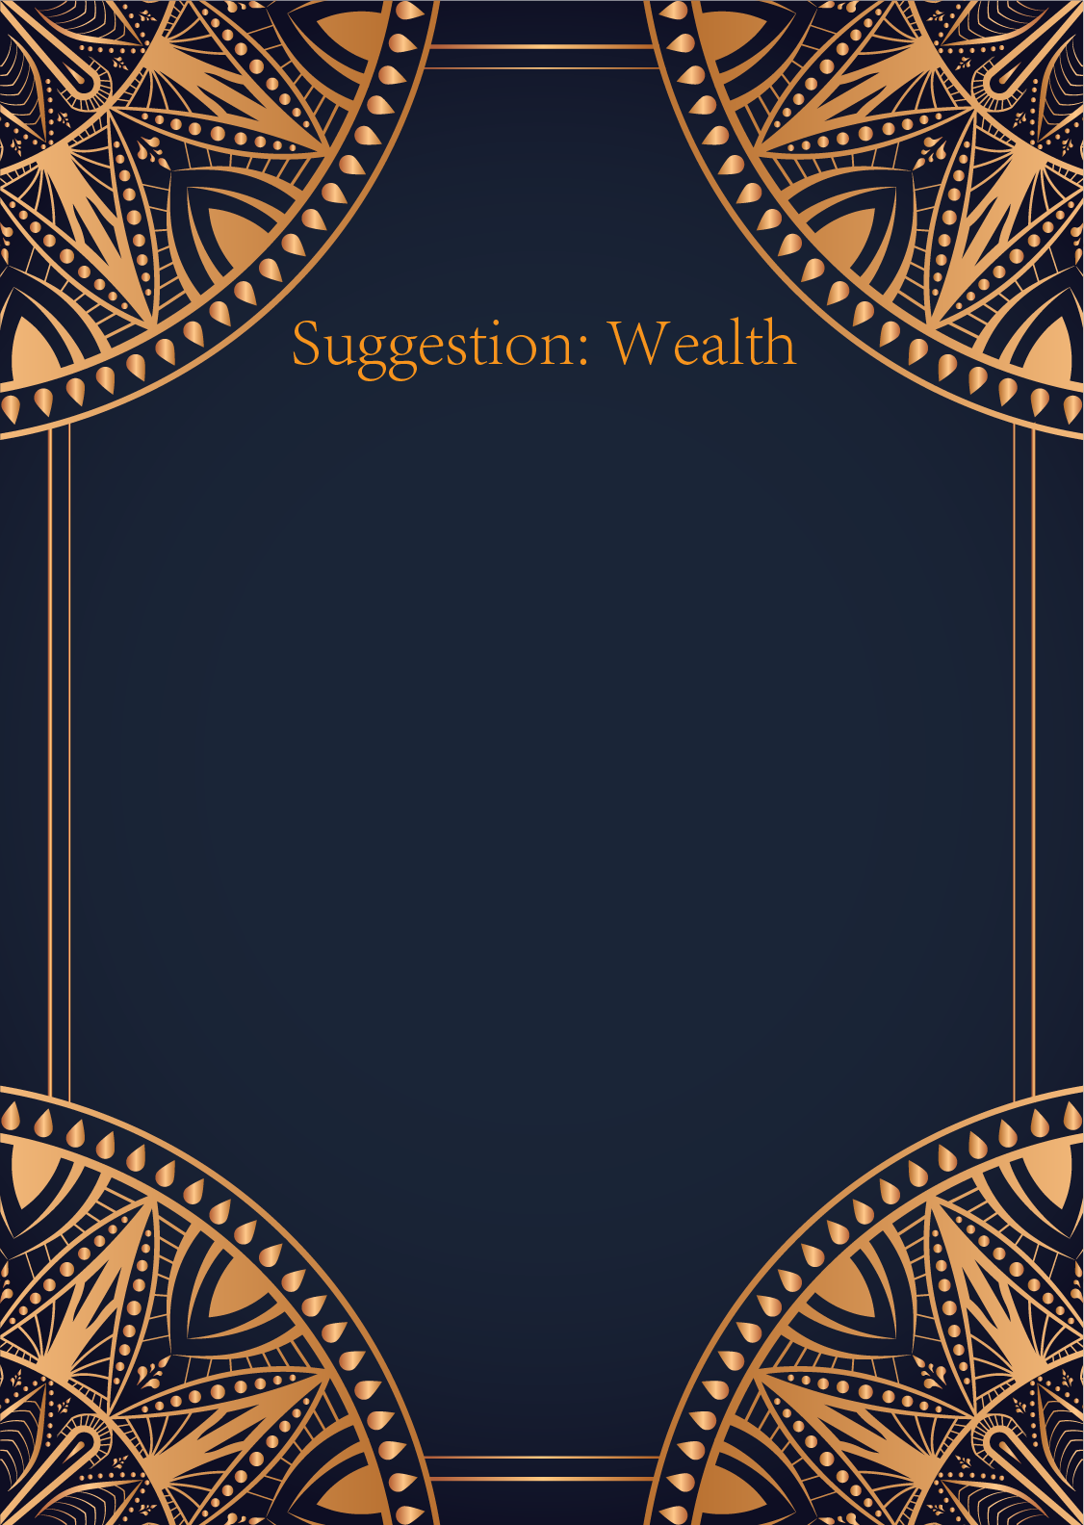

|  |
| --- |
| {{#wealth_suggestion}} |

